·Team Leader: NA GAO
·Submission name: Green Bean Plan by G&G
·Short description:
Individual green behaviours’ bonus points system based on blockchain technology.
·Long description:
In recent years, natural and humanitarian disasters such as glacier melting,species extinction,extreme drought and food crisis caused by human carbon-intensive activities have make people realize we need to join together,look for win-wins,and be fair to address climate change, our most global challenge.
But the”Turning Brown to Green” transformation process is usually accompanied by high risks - the market acceptance of green innovative products is insufficient, and it is difficult to achieve sustainable operation and stable development purely relied on government subsidies or public donations.
Inspired by the Two Mountains Theory”Lucid waters and lush mountains are invaluable assets”,we believe individual green behaviours can produce economic value by technology-Green is Gold.
”Green Bean Plan”,namely individual green behaviours’ bonus points system based on blockchain technology,can support establishing an online account based on smart contract,depositing,paying,transferring and donation to public welfare fundations in the blockchain network with e-commerces,financial organizations and public fundations.The beans can be accumulated by green consumption,production and investment,and support to be used as currencies in future green behaviours.Compared to buy regular appliances,more consumers are willing to choose energy saving appliances in order to get extra bonus points to deposit green beans.
Individual green behaviours such as consuming energy saving domestic appliances,electric vehicles,public transport,local vegetables and fruits,clothes made by recycled material,vegetarian restaurants’ meal,applying for loans engaged into green productions,investing green financial products such as green bonds,those currencies caused can be converted into green beans according to the ratio of 100:1,the beans support to be used as currencies according to the ratio of 1:1 in the next green consumption, production,or investment ,and the excess currencies amount can also be converted into beans by the ratio of 100:1.
Furthemore,The green bean account supports transferring and donating to the public foundations aiming for environmental protection or caring for the vulnerable and poor to get green consumption or set up own green business,so we can achieve the goal of working together, looking for win-wins, and being fair to address climate change.
Above all,Green bean is also golden bean,carbon neutralization should also be good for economic growth and more jobs.Every individual's subtle and various daily green behaviors can promote the rapid development of green industry and economic transition,bring social welfare of environmental protection and mutual love.

Solutionroadmap:
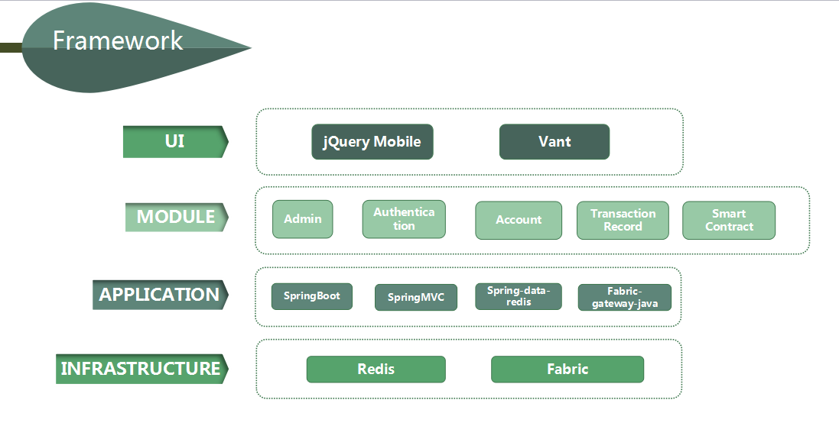
Link to publicly accessible GitHub repository:
https://github.com/xandon01/lvdou-2021callforcode

Link to a three-minute demo video:
https://github.com/xandon01/lvdou-2021callforcode

